**CLUSTER Toolkit for Outbreak Response**



This protocol was developed as part of the CLUSTER Trial

Baker MB, Septimus EJ, Kleinman K, et al. A Trial of Automated Outbreak Detection to Reduce Hospital Pathogen Spread. NEJM Evidence 2024; 3 (5) [DOI: 10.1056/EVIDoa2300342](https://evidence.nejm.org/doi/full/10.1056/EVIDoa2300342)

# CLUSTER Toolkit Authors

**Harvard Medical School / Harvard Pilgrim Health Care Institute**

Meghan Baker, M.D., Sc.D.

Ed Septimus, M.D.

Richard Platt, M.D., M.S.

**University of California Irvine**

Susan Huang, M.D., M.P.H.

**HCA Healthcare**

Julia Moody, M.S.

Eunice J. Blanchard, M.S.N., R.N.

Kenneth Sands, M.D., M.P.H.

**University of California San Francisco**

Deborah Yokoe, M.D. M.P.H.

**Duke University**

Sarah S. Lewis, M.D., M.P.H.

**Rush University**

Michael Lin, M.D., M.P.H.

Robert Weinstein, M.D. (also associated with Cook County Health and Hospitals System)

**Table of Contents**

Introduction3

Outbreak Response Protocol: Quick Guides4

QUICK GUIDE: Tier 15

QUICK GUIDE: Tier 214

Overview Cling23

Activation Checklist – Initial Alert & Progression24

Outbreak Response Protocol: Intervention Details 26

Initial Response27

Tiers 1-5 Interventions33

Outbreak Case List 42

Unit Notification45

Huddle Guidance47

Practice Assessments: Forms & Guidance Documents 49

Hand Hygiene50

Contact Precautions51

Environmental Cleaning: UV Marker52

Environmental Cleaning: ATP Users53

Chlorhexidine Bathing (for Patient Decolonization interventions)54

Hand Hygiene Compliance Guidance55

High Touch Surface Image Guide56

UV Marker Removal Image Guide57

Chlorhexidine Bathing Instructions59

Nasal Mupirocin Application Instructions60

Nasal Iodophor Application Instructions61

Outbreak Response Logs62

# 

# Introduction

The Outbreak Response Protocol provides a standardized approach to outbreaks of infections occurring in hospitals. The response protocol is focused on bacterial, mycobacterial and fungal pathogens although it could be applied to viruses. The protocol provides options for intervention when an infectious outbreak is detected in a hospital or healthcare facility. It includes an initial response plan as well as escalating tiers of strategic response if additional cases occur. Each tier requires an assessment by the infection prevention program and a response tailored to the findings of the assessment (e.g., improve hand hygiene if compliance found to be low in the setting of a cluster).

This outbreak response protocol was developed as part of the [CLUSTER (**C**luster **L**inkage **U**sing **S**tatistics to **T**rigger and **E**valuate **R**esponse) Trial](https://evidence.nejm.org/doi/full/10.1056/EVIDoa2300342) to assess a statistically-based automated tool to improve detection of hospital outbreaks.

**Outbreak Response Protocol:**

**Quick Guides**

# Tier 1 Quick Guide

# Outbreak Response Activation Checklist:

# Initial Outbreak Alert

**Day 1: Initial outbreak identification**

**Step 1:** Outbreak detection

**Step 2:** Notify unit (see *Notification Email*), provide *Staff Huddle* documents & notify appropriate staff

**Step 3:** Begin initial practice assessments:  *Hand Hygiene Assessment*

*Contact Precautions Assessment (if applicable)*

*Environmental Cleaning Assessment*

**Day 2**

**Step 4:** Select & begin at least **ONE INTERVENTION** based on practice assessment results 🡪

**OPTION 1**

If inadequate hand hygiene or contact precautions (<80% successful), **PICK ONE:**

Improve hand hygiene (feedback, huddles)

Improve contact precautions adherence (feedback, huddles)

**OPTION 2**

If inadequate adherence to environmental cleaning (<80% marks removed), **PICK ONE:**

Improve quality of cleaning (feedback, retraining)

Coordinated unit clean (conducted daily)

Additional cleaning of high touch areas

**Step 5:** Record outbreak & intervention information in *Day 1-2 Outbreak Response Log*

**Step 6:** Consider collection of isolates with microbiology lab for further genetic analysis

**Days 3 to 21**

**Step 7:** Continue selected intervention for 3 weeks from the date of the last case (see *Outbreak Response Protocol*)

**Step 8:** Repeat the practice assessment relevant to the selected intervention **weekly,** until at least 3 weeks have passed from the date of the last case

Weekly Assessments Log

Day 7

Day 14

Day 21

**Step 9:** Complete *Weekly Intervention Log* on weekly basis for duration of intervention

# Outbreak Response: Alert Unit

**Notify unit of outbreak**

* Call unit nursing and medical leadership
* Email key actions to leaders using an email template

**PLEASE NOTE:** Sample language and talking points can be updated by individual hospitals to reflect any facility-specific guidance or activities required. **Sample text below:**

Subject Header: Outbreak Alert on Your Unit

Dear Nursing Supervisor:

An outbreak of XXX has been detected on your unit. Please do the following:

* Inform all shifts about the outbreak using the outbreak huddle document.
* Remind staff:
  + Vigilant hand hygiene, including before and after glove use;
  + For patients on Contact Precautions, practice appropriate use of personal protective equipment; and
  + Disinfect equipment and devices after each patient use.
* Monitoring of hand hygiene, contact precautions (if applicable) and environmental cleaning is ongoing. Infection Control or other staff members will be visiting your unit to discuss how best to respond to the outbreak to protect your patients.

Sincerely,

XXX

# Staff Huddle: Outbreak

* An outbreak of XXX has been detected on this unit
* All unit staff to assure:
  + High compliance with hand hygiene
  + Proper use of personal protective equipment for patients on Contact Precautions
  + Disinfection of equipment and devices after patient use
* Your unit manager will work with infection prevention and hospital leadership on next steps to best address this outbreak

# Hand Hygiene Assessment

**Date: ____/_____/________ Time: _____:______ AM/PM**

**Facility Name: _____________________________ Unit Name: ______________________________________**

**Assessment Type (Check): ___Initial Assessment Repeat Assessment:** ___Week 1 ___Week 2 ___Week 3

**Observer: __________________________________ Outbreak descriptor: ______________________________**

**Instructions**:

If Partially Compliant, indicate deficiency with **Quick Note: (A)** Insufficient hand gel used

**(B)** Hands rinsed with water only (no soap)

**(C)** Poor technique (brief rub, little surface covered)

|  |  |  |  |  |  |  |  |  |  |
| --- | --- | --- | --- | --- | --- | --- | --- | --- | --- |
|  | **Room #** | **Type of Observation** | **Hand Hygiene Attempt**  (check appropriate) | | | **Compliance\***  (check appropriate) | | | **Quick Notes**  (if Partially Compliant) |
|  |  | Entry, Exit, Other | Wash | Rub | None | Full | Partial | None | Indicate A, B or C |
| 1 |  |  |  |  |  |  |  |  |  |
| 2 |  |  |  |  |  |  |  |  |  |
| 3 |  |  |  |  |  |  |  |  |  |
| 4 |  |  |  |  |  |  |  |  |  |
| 5 |  |  |  |  |  |  |  |  |  |
| 6 |  |  |  |  |  |  |  |  |  |
| 7 |  |  |  |  |  |  |  |  |  |
| 8 |  |  |  |  |  |  |  |  |  |
| 9 |  |  |  |  |  |  |  |  |  |
| 10 |  |  |  |  |  |  |  |  |  |

**\*** See *Hand Hygiene Compliance Criteria* within toolkit for additional guidance

**Overall Hand Hygiene Adherence Rate** (# compliant observations / # total observations)**: __________________%**

* ‘Partially Compliant’ not considered compliant towards adherence rate
* <80% considered poor adherence

# Contact Precautions Assessment

**Date: ____/_____/________ Time: _____:______ AM/PM**

**Facility Name: _____________________________ Unit Name: ______________________________________**

**Assessment Type (Check): ___Initial Assessment Repeat Assessment:** ___Week 1 ___Week 2 ___Week 3

**Observer: __________________________________ Outbreak descriptor: ___ ___________________________**

**Instructions**: (1) Indicate Room # being observed & if observation is of room entry or exit

(2) Indicate observed compliance for relevant tasks (completed appropriately: **Yes** or **No**)

|  |  |  |  |  |  |
| --- | --- | --- | --- | --- | --- |
|  | **Observation 1**  Room #: ______  Circle: Entry/Exit | **Observation 2**  Room #: ______  Circle: Entry/Exit | **Observation 3**  Room #: ______  Circle: Entry/Exit | **Observation 4**  Room #: ______  Circle: Entry/Exit | **Observation 5**  Room #: ______  Circle: Entry/Exit |
| **ACTIVITY** | **COMPLIANCE (Yes or No)** | | | | |
| **Observation at Room Entry** (skip this section for observations of room exit) | | | | | | |
| 1. Hand hygiene performed immediately prior to putting on gown & gloves | Yes  No | Yes  No | Yes  No | Yes  No | Yes  No |
| 1. New gown & gloves applied prior to entering room | Yes  No | Yes  No | Yes  No | Yes  No | Yes  No |
| **Observation at Room Exit** (skip this section for observations of room entry) | | | | | | |
| 1. Gown & gloves are removed immediately before or after room exit | Yes  No | Yes  No | Yes  No | Yes  No | Yes  No |
| 1. Hand hygiene performed immediately after gown & gloves are removed | Yes  No | Yes  No | Yes  No | Yes  No | Yes  No |

**Overall Contact Precautions Adherence Rate** (# successful observations / # total observations) = _____________%

* Observation is successful if the all relevant tasks are done correctly
* <80% considered poor adherence

# Environmental Cleaning Assessment:

# UV Blacklight Marker

**Date: ____/_____/________ Time: _____:______ AM/PM**

**Facility Name: _____________________________ Unit Name: ______________________________________**

**Assessment Type (Check): ___Initial Assessment Repeat Assessment:** ___Week 1 ___Week 2 ___Week 3

**Observer: __________________________________ Outbreak descriptor: ______________________________**

**CLEANING OUTCOME**

**0** = Not Removed

**1** = Removed

**Instructions for using UV Marker:**

**(1) Prior to daily cleaning –** Mark high touch surfaces* with UV marker **(2) After daily cleaning –** Using UV light, assess whether marks were removed**+**

|  |  |  |  |  |  |  |
| --- | --- | --- | --- | --- | --- | --- |
| **High-Touch Room Surfaces\*** | **Room 1**  **PICK 5+** | **Room 2**  **PICK 5+** | **Room 3**  **PICK 5+** | **Room 4**  **PICK 5+** | **Room 5**  **PICK 5+** | **Room 6**  **PICK 5+** |
| *Example* | *1* | *1* | *0* | *1* | *0* | *1* |
| Bed Rails / Bed Controls |  |  |  |  |  |  |
| Telephone |  |  |  |  |  |  |
| Call Button |  |  |  |  |  |  |
| Bedside Table |  |  |  |  |  |  |
| Door Knobs |  |  |  |  |  |  |
| Light Switch |  |  |  |  |  |  |
| Patient Sink Handle |  |  |  |  |  |  |
| Sanitizer Dispenser Button |  |  |  |  |  |  |
| Bathroom Sink Handle |  |  |  |  |  |  |
| Toilet |  |  |  |  |  |  |
| Toilet Flush Handle |  |  |  |  |  |  |
| Bathroom Hand Rails |  |  |  |  |  |  |
| Other: ___________________ |  |  |  |  |  |  |

*See *High Touch Surface Image Guide* within toolkit for suggested target surfaces

**+**See *UV Marker Removal Image Guide* within toolkit for guidance on interpreting cleaning outcome

**Overall Cleaning Adherence Rate** ((# clean surfaces / # total observed surfaces) = _________________%

* Individual surface is successfully cleaned if at least 80% of UV marking was removed
* <80% successfully cleaned surfaces overall considered poor adherence

# Environmental Cleaning Assessment: ATP

**Date: ____/_____/________ Time: _____:______ AM/PM**

**Facility Name: _____________________________ Unit Name: ______________________________________**

**Assessment Type (Check): ___Initial Assessment Repeat Assessment:** ___Week 1 ___Week 2 ___Week 3

**Observer: __________________________________ Outbreak descriptor: ______________________________**

**Instructions for ATP Users:**

**CLEANING OUTCOME**

**0** = Fail

**1** = Pass

**Immediately following daily room cleaning –** Test high touch surfaces* for ATP

to determine if surface has been sufficiently cleaned, indicate below.

**Follow manufacturer’s instruction for pass/fail threshold**

|  |  |  |  |  |  |  |
| --- | --- | --- | --- | --- | --- | --- |
| **High-Touch Room Surfaces\*** | **Room 1**  **PICK 5+** | **Room 2**  **PICK 5+** | **Room 3**  **PICK 5+** | **Room 4**  **PICK 5+** | **Room 5**  **PICK 5+** | **Room 6**  **PICK 5+** |
| *Example Object* | *1* | *1* | *0* | *1* | *0* | 1 |
| Bed Rails / Bed Controls |  |  |  |  |  |  |
| Telephone |  |  |  |  |  |  |
| Call Button |  |  |  |  |  |  |
| Bedside Table |  |  |  |  |  |  |
| Door Knobs |  |  |  |  |  |  |
| Light Switch |  |  |  |  |  |  |
| Patient Sink Handle |  |  |  |  |  |  |
| Sanitizer Dispenser Button |  |  |  |  |  |  |
| Bathroom Sink Handle |  |  |  |  |  |  |
| Toilet |  |  |  |  |  |  |
| Toilet Flush Handle |  |  |  |  |  |  |
| Bathroom Hand Rails |  |  |  |  |  |  |
| Other: ___________________ |  |  |  |  |  |  |

*See *High Touch Surface Image Guide* within toolkit for suggested target surfaces

**Overall Cleaning Adherence Rate** (# clean surfaces / # total observed surfaces) = _________________%

* Individual surface is successfully cleaned if below the manufacturer’s instructions for pass/fail threshold
* <80% successfully cleaned surfaces overall considered poor adherence

# 

# Day 1-2 Outbreak Response Log

**Facility Name: _________________________________ Submitted By: ________________________________**

1. Outbreak Details:
   1. How was the outbreak identified (describe): Click or tap here to enter text.
   2. Outbreak descriptor: Click or tap here to enter text.
   3. Date & Time when the outbreak was identified: Enter MMDDYY; 00:00 AM/PM
   4. Date & Time of collection of first isolate in outbreak: Enter MMDDYY; 00:00 AM/PM
   5. Number of patients when outbreak was identified: Click or tap here to enter text.
2. Organism: Click or tap here to enter text.
3. Unit Director notification: Y/N 3a. Date & Time: Enter MMDDYY; 00:00 AM/PM
4. Huddles with clinical staff have occurred: Y/N
5. Complete initial practice assessments (using Outbreak Response Assessment Forms) & record results:
   1. Hand Hygiene Adherence Rate: ___________________%
   2. Contact Precautions Adherence Rate: ______________% (Check here if N/A and not completed: )
   3. Environmental Cleaning Adherence Rate: ___________%
6. Intervention Selected:
   1. Improve hand hygiene
   2. Improve contact precautions adherence
   3. Improve quality of cleaning
   4. Coordinated unit clean daily
   5. Additional cleaning of high touch areas
   6. Other (specify below)
7. Intervention implementation Date & Time: Enter MMDDYY; 00:00 AM/PM
   1. Description of Intervention (indicate reason for selection, e.g. poorest adherence rate): Click or tap here to enter text.
8. Additional Comments: Click or tap here to enter text.

# Tier 2 Quick Guide

# Outbreak Response Activation Checklist:

# Progression

**Definition of Outbreak Progression:**

A new case identified as part of an existing outbreak.

**Day 1: Additional case notification**

**Step 1:** Identify one or more cases as part of an existing outbreak.

**Step 2:** Notify unit and appropriate staff.

**Step 3:** Repeat all practice assessments  *Hand Hygiene Assessment*

(if >1 week has passed since initial assessments)  *Contact Precautions Assessment (if applicable)*

*Environmental Cleaning Assessment*

**Day 2**

**Step 4:** Select & begin at least **ONE ADDITIONAL INTERVENTION** based on assessment results

**OPTION 1**

If inadequate hand hygiene or contact precautions (<80% successful), **PICK ONE:**

Improve hand hygiene (feedback, huddles)

Improve contact precautions adherence (feedback, huddles)

Add universal glove precautions

Add contact precautions for all patients in the outbreak

**OPTION 2**

If inadequate adherence to environmental cleaning (<80% marks removed), **PICK ONE:**

Improve quality of cleaning (feedback, retraining)

Coordinated unit clean (conducted daily)

Additional cleaning of high touch area

**Step 5:** Record outbreak & intervention information in *Day 1-2 Outbreak Response Log: Progressions*

**Step 6:** Consider collection of isolates with microbiology lab for further genetic analysis

**Days 3 to 21**

**Step 7:** Continue all selected interventions for 3 weeks from the date of the last case (see *Outbreak Response Protocol*)

**Step 8**: Repeat practice assessment(s) relevant to selected intervention(s) **weekly,** until at least 3 weeks have passed from the date of the last case

Weekly Assessments Log

Day 7

Day 14

Day 21

**Step 9:** Complete *Weekly Intervention Log* on weekly basis for duration of intervention

# Outbreak Progression: Alert Unit

**Notify unit of outbreak progression**

* Call unit nursing and medical leadership
* Email key actions to leaders using an email template

**PLEASE NOTE:** Sample language and talking points can be updated by individual hospitals to reflect any facility-specific guidance or activities required. **Sample text below:**

Subject Header: Outbreak Alert on Your Unit

Dear Nursing Supervisor:

A new case has been identified for the existing outbreak of XXX on your unit. Please do the following:

* Inform all shifts about the expanding outbreak using the outbreak huddle document.
* Remind staff:
  + Vigilant hand hygiene, including before and after glove use;
  + For patients on Contact Precautions, practice appropriate use of personal protective equipment; and
  + Disinfect equipment and devices after each patient use.
* Monitoring of hand hygiene, contact precautions (if applicable) and environmental cleaning is ongoing. Infection Control or other staff members will be visiting your unit to discuss how best to respond to the outbreak to protect your patients.

Sincerely,

XXX

# Staff Huddle: Outbreak Progression

* The existing outbreak of XXX on this unit has progressed.
* All unit staff to assure:
  + High compliance with hand hygiene
  + Proper use of personal protective equipment for patients on Contact Precautions
  + Disinfection of equipment and devices after patient use
* Your unit manager will work with infection prevention and hospital leadership on next steps to best address this outbreak

# Hand Hygiene Assessment

**Date: ____/_____/________ Time: _____:______ AM/PM**

**Facility Name: _____________________________ Unit Name: ______________________________________**

**Assessment Type (Check): ___Initial Assessment Repeat Assessment:** ___Week 1 ___Week 2 ___Week 3

**Observer: __________________________________ Outbreak descriptor: ______________________________**

**Instructions**:

If Partially Compliant, indicate deficiency with **Quick Note: (A)** Insufficient hand gel used

**(B)** Hands rinsed with water only (no soap)

**(C)** Poor technique (brief rub, little surface covered)

|  |  |  |  |  |  |  |  |  |  |
| --- | --- | --- | --- | --- | --- | --- | --- | --- | --- |
|  | **Room #** | **Type of Observation** | **Hand Hygiene Attempt**  (check appropriate) | | | **Compliance\***  (check appropriate) | | | **Quick Notes**  (if Partially Compliant) |
|  |  | Entry, Exit, Other | Wash | Rub | None | Full | Partial | None | Indicate A, B or C |
| 1 |  |  |  |  |  |  |  |  |  |
| 2 |  |  |  |  |  |  |  |  |  |
| 3 |  |  |  |  |  |  |  |  |  |
| 4 |  |  |  |  |  |  |  |  |  |
| 5 |  |  |  |  |  |  |  |  |  |
| 6 |  |  |  |  |  |  |  |  |  |
| 7 |  |  |  |  |  |  |  |  |  |
| 8 |  |  |  |  |  |  |  |  |  |
| 9 |  |  |  |  |  |  |  |  |  |
| 10 |  |  |  |  |  |  |  |  |  |

**\*** See *Hand Hygiene Compliance Criteria* within toolkit for additional guidance

**Overall Hand Hygiene Adherence Rate** (# compliant observations / # total observations)**: __________________%**

* ‘Partially Compliant’ not considered compliant towards adherence rate
* <80% considered poor adherence

# Contact Precautions Assessment

**Date: ____/_____/________ Time: _____:______ AM/PM**

**Facility Name: _____________________________ Unit Name: ______________________________________**

**Assessment Type (Check): ___Initial Assessment Repeat Assessment:** ___Week 1 ___Week 2 ___Week 3

**Observer: __________________________________ Outbreak descriptor: ______________________________**

**Instructions**: (1) Indicate Room # being observed & if observation is of room entry or exit

(2) Indicate observed compliance for relevant tasks (completed appropriately: **Yes** or **No**)

|  |  |  |  |  |  |
| --- | --- | --- | --- | --- | --- |
|  | **Observation 1**  Room #: ______  Circle: Entry/Exit | **Observation 2**  Room #: ______  Circle: Entry/Exit | **Observation 3**  Room #: ______  Circle: Entry/Exit | **Observation 4**  Room #: ______  Circle: Entry/Exit | **Observation 5**  Room #: ______  Circle: Entry/Exit |
| **ACTIVITY** | **COMPLIANCE (Yes or No)** | | | | |
| **Observation at Room Entry** (skip this section for observations of room exit) | | | | | | |
| 1. Hand hygiene performed immediately prior to putting on gown & gloves | Yes  No | Yes  No | Yes  No | Yes  No | Yes  No |
| 1. New gown & gloves applied prior to entering room | Yes  No | Yes  No | Yes  No | Yes  No | Yes  No |
| **Observation at Room Exit** (skip this section for observations of room entry) | | | | | | |
| 1. Gown & gloves are removed immediately before or after room exit | Yes  No | Yes  No | Yes  No | Yes  No | Yes  No |
| 1. Hand hygiene performed immediately after gown & gloves are removed | Yes  No | Yes  No | Yes  No | Yes  No | Yes  No |

**Overall Contact Precautions Adherence Rate** (# successful observations / # total observations) = _____________%

* Observation is successful if the all relevant tasks are done correctly
* <80% considered poor adherence

# Environmental Cleaning Assessment:

# UV Blacklight Marker

**Date: ____/_____/________ Time: _____:______ AM/PM**

**Facility Name: _____________________________ Unit Name: ______________________________________**

**Assessment Type (Check): ___Initial Assessment Repeat Assessment:** ___Week 1 ___Week 2 ___Week 3

**Observer: __________________________________ Outbreak descriptor: ______________________________**

**CLEANING OUTCOME**

**0** = Not Removed

**1** = Removed

**Instructions for using UV Marker:**

**(1) Prior to daily cleaning –** Mark high touch surfaces* with UV marker **(2) After daily cleaning –** Using UV light, assess whether marks were removed**+**

|  |  |  |  |  |  |  |
| --- | --- | --- | --- | --- | --- | --- |
| **High-Touch Room Surfaces\*** | **Room 1**  **PICK 5+** | **Room 2**  **PICK 5+** | **Room 3**  **PICK 5+** | **Room 4**  **PICK 5+** | **Room 5**  **PICK 5+** | **Room 6**  **PICK 5+** |
| *Example* | *1* | *1* | *0* | *1* | *0* | *1* |
| Bed Rails / Bed Controls |  |  |  |  |  |  |
| Telephone |  |  |  |  |  |  |
| Call Button |  |  |  |  |  |  |
| Bedside Table |  |  |  |  |  |  |
| Door Knobs |  |  |  |  |  |  |
| Light Switch |  |  |  |  |  |  |
| Patient Sink Handle |  |  |  |  |  |  |
| Sanitizer Dispenser Button |  |  |  |  |  |  |
| Bathroom Sink Handle |  |  |  |  |  |  |
| Toilet |  |  |  |  |  |  |
| Toilet Flush Handle |  |  |  |  |  |  |
| Bathroom Hand Rails |  |  |  |  |  |  |
| Other: ___________________ |  |  |  |  |  |  |

*See *High Touch Surface Image Guide* within toolkit for suggested target surfaces

**+**See *UV Marker Removal Image Guide* within toolkit for guidance on interpreting cleaning outcome

**Overall Cleaning Adherence Rate** ((# clean surfaces / # total observed surfaces) = _________________%

* Individual surface is successfully cleaned if at least 80% of UV marking was removed
* <80% successfully cleaned surfaces overall considered poor adherence

# Environmental Cleaning Assessment: ATP

**Date: ____/_____/________ Time: _____:______ AM/PM**

**Facility Name: _____________________________ Unit Name: ______________________________________**

**Assessment Type (Check): ___Initial Assessment Repeat Assessment:** ___Week 1 ___Week 2 ___Week 3

**Observer: __________________________________ Outbreak descriptor: ______________________________**

**Instructions for ATP Users:**

**CLEANING OUTCOME**

**0** = Fail

**1** = Pass

**Immediately following daily room cleaning –** Test high touch surfaces* for ATP

to determine if surface has been sufficiently cleaned, indicate below.

**Follow manufacturer’s instruction for pass/fail threshold**

|  |  |  |  |  |  |  |
| --- | --- | --- | --- | --- | --- | --- |
| **High-Touch Room Surfaces\*** | **Room 1**  **PICK 5+** | **Room 2**  **PICK 5+** | **Room 3**  **PICK 5+** | **Room 4**  **PICK 5+** | **Room 5**  **PICK 5+** | **Room 6**  **PICK 5+** |
| *Example Object* | *1* | *1* | *0* | *1* | *0* | 1 |
| Bed Rails / Bed Controls |  |  |  |  |  |  |
| Telephone |  |  |  |  |  |  |
| Call Button |  |  |  |  |  |  |
| Bedside Table |  |  |  |  |  |  |
| Door Knobs |  |  |  |  |  |  |
| Light Switch |  |  |  |  |  |  |
| Patient Sink Handle |  |  |  |  |  |  |
| Sanitizer Dispenser Button |  |  |  |  |  |  |
| Bathroom Sink Handle |  |  |  |  |  |  |
| Toilet |  |  |  |  |  |  |
| Toilet Flush Handle |  |  |  |  |  |  |
| Bathroom Hand Rails |  |  |  |  |  |  |
| Other: ___________________ |  |  |  |  |  |  |

*See *High Touch Surface Image Guide* within toolkit for suggested target surfaces

**Overall Cleaning Adherence Rate** (# clean surfaces / # total observed surfaces) = _________________%

* Individual surface is successfully cleaned if below the manufacturer’s instructions for pass/fail threshold
* <80% successfully cleaned surfaces overall considered poor adherence

# Day 1-2 Outbreak Response Log: TIER 2 Progression of Outbreak

**Facility Name: _________________________________ Submitted By: _________________________________**

1. Outbreak Progression Details:
   1. Outbreak descriptor: Click or tap here to enter text.
   2. Date & Time when outbreak progression was identified: Enter MMDDYY; 00:00 AM/PM
   3. Date & Time of collection of most recent isolate: Enter MMDDYY; 00:00 AM/PM
   4. Number of additional patients: Click or tap here to enter text.
   5. Please describe how the outbreak has progressed: Click or tap here to enter text.
2. Huddles with clinical staff have occurred: Y/N
3. Complete repeat practice assessments (if >1week has passed since initial assessments) & record results:
4. Hand Hygiene Adherence Rate: ___________________%
5. Contact Precaution Adherence Rate: _______________% (Check here if N/A and not completed: )
6. Environmental Cleaning Adherence Rate: ___________%
7. Tier 2 intervention selected:
   1. Improve hand hygiene
   2. Improve contact precaution adherence
   3. Add universal glove precautions
   4. Add contact precautions for outbreak patients
   5. Improve quality of cleaning
   6. Coordinated unit clean daily
   7. Additional cleaning of high touch areas
   8. Other (specify below)
8. Second intervention implementation Date & Time: Enter MMDDYY; 00:00 AM/PM
   1. Description of intervention (indicate reason for selection, e.g. poorest adherence rate): Click or tap here to enter text.
9. Additional Comments: Click or tap here to enter text.

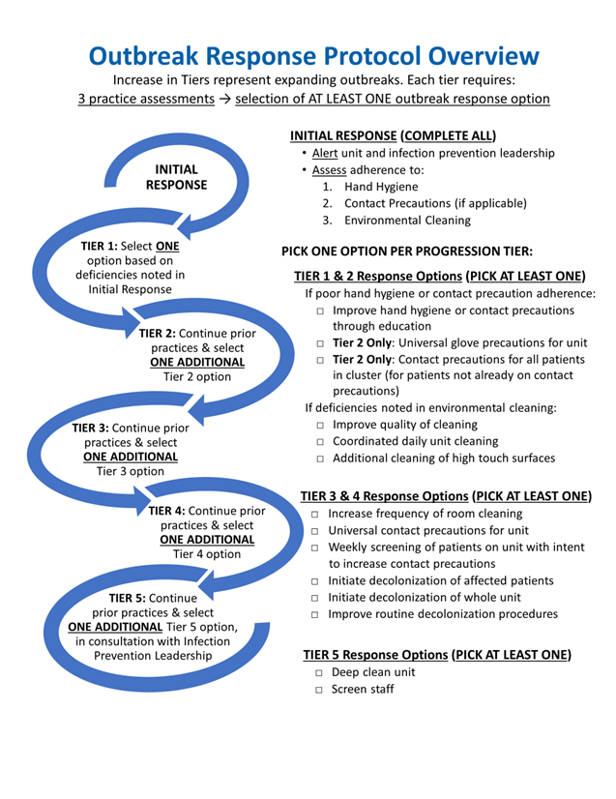

# Outbreak Response Activation Checklist:

# Initial Outbreak Alert

**Day 1: Initial outbreak identification**

**Step 1:** Outbreak detection

**Step 2:** Notify unit (see *Notification Email*), provide *Staff Huddle* documents & notify appropriate staff

**Step 3:** Begin initial practice assessments:  *Hand Hygiene Assessment*

*Contact Precautions Assessment (if applicable)*

*Environmental Cleaning Assessment*

**Day 2**

**Step 4:** Select & begin at least **ONE INTERVENTION** based on practice assessment results 🡪 for intervention details, see *Outbreak Response Protocol*

**Step 5:** Record outbreak & intervention information in *Day 1-2 Outbreak Response Log*

**Step 6:** Consider collection of isolates with microbiology lab for further genetic analysis

**Days 3 to 21**

**Step 7:** Continue selected intervention for 3 weeks from the date of the last case (see *Outbreak Response Protocol*)

**Step 8:** Repeat the practice assessment relevant to the selected intervention **weekly,** until at least 3 weeks have passed from the date of the last case

Weekly Assessments Log

Day 7

Day 14

Day 21

**Step 9:** Complete *Weekly Intervention Log* on weekly basis for duration of intervention

# Outbreak Response Activation Checklist:

# Outbreak Progression

**Definition of Outbreak Progression:**

A new case identified as part of an existing outbreak.

**Day 1: Additional case notification**

**Step 1:** Identify one or more cases as part of an existing outbreak.

**Step 2:** Notify unit and appropriate staff.

**Step 3:** Repeat all practice assessments  *Hand Hygiene Assessment*

(if >1 week has passed since initial assessments)  *Contact Precautions Assessment (if applicable)*

*Environmental Cleaning Assessment*

**Day 2**

**Step 4:** Select & begin at least **ONE ADDITIONAL INTERVENTION** based on assessment results & tier 🡪 for intervention details, see *Outbreak Response Protocol*

**Step 5:** Record outbreak & intervention information in *Day 1-2 Outbreak Response Log: Progressions*

**Step 6:** Consider collection of isolates with microbiology lab for further genetic analysis

**Days 3 to 21**

**Step 7:** Continue all selected interventions for 3 weeks from the date of the last case (see *Outbreak Response Protocol*)

**Step 8**: Repeat practice assessment(s) relevant to selected intervention(s) **weekly,** until at least 3 weeks have passed from the date of the last case

Weekly Assessments Log

Day 7

Day 14

Day 21

**Step 9:** Complete *Weekly Intervention Log* on weekly basis for duration of intervention

**Outbreak Response Protocol:**

**Intervention Details**

# Outbreak Response Protocol: INITIAL RESPONSE

| **ELEMENTS** | **DETAILED DESCRIPTION** |
| --- | --- |
| **Initial Response** | Following identification of an outbreak, complete all mandatory Initial Response tasks & assessments, before selecting a Tier 1 Intervention Option**.**  **PLEASE NOTE**: If an outbreak is identified over the weekend or on a holiday, initiate alert notification and huddles, and begin assessments when possible (at latest, the next business day). |
| **Alert Unit & Lab Personnel** | **Notify the Unit**: Please find “Outbreak Response: Alert Unit” document for an email template.  Consider collection of isolates with microbiology lab for future genetic analysis. |
| **Team Huddle** | **Conduct team huddle** with nursing or medical director, nursing staff and environmental services to discuss the outbreak and the response plan.  See *Staff Huddle: Outbreak* document for further guidance. |
| Practice Assessments: **Hand Hygiene**  Assess adherence | Designated staff trained in hand hygiene monitoring should observe **at least 5 hand hygiene opportunities per 10 unit beds** for 5 different healthcare workers in units where the outbreak was detected, and record hand hygiene adherence using the *Hand Hygiene Assessment Form* in the toolkit.  ***Who should do the assessment?*** This decision is based upon what has been agreed upon or what is usual practice at your hospital. For example, this could be a unit nursing director/manager, designated nursing staff, infection preventionist, trained ancillary staff or volunteer.  ***Hand hygiene opportunities*** refers to room entry, room exit, or in-room opportunities per the 5 WHO moments (note: the observer must have full view to assess the opportunity). Opportunities include:   * washing with soap and water * using alcohol-based hand rub   **Appropriate hand hygiene:**   * Washing hands with soap and water for 15 seconds * Rubbing approved hand sanitizer on all hand surfaces * If gloves are used, hand hygiene performed prior to donning gloves and after removal * For *C. difficile* precaution rooms, healthcare personnel must perform hand hygiene (e.g. soap and water) upon exit, in accordance with hospital policy. * Please see the *Hand Hygiene Compliance Criteria* for additional guidance   Observers are encouraged to provide real-time feedback to healthcare workers to correct hand hygiene practices, while recording originally observed practices in assessment form. |

|  |  |
| --- | --- |
| Practice Assessments: **Contact Precautions (Gown & Glove)**  Assess adherence, if applicable | **If the outbreak organism is one that involves contact precautions, perform this assessment. Otherwise, SKIP.**  Designated staff trained in contact precautions monitoring should observe **at least 5 contact precaution opportunities per involved unit** for 5 different health care workers, and record adherence using the *Contact Precautions Assessment Form* in the toolkit.  ***Who should do the assessment?*** This decision is based upon what has been agreed upon or what is usual practice at your hospital. For example, this could be a unit nursing director/manager, designated nursing staff, infection preventionist, trained ancillary staff or volunteer.  ***Contact Precaution opportunities*** refer to donning on entry or doffing on exit from room.  **Appropriate use of contact precautions:**   * Perform hand hygiene. * Don gown & gloves just prior to room entry. Gown should be secured at neck and waist. * Gowns & gloves removed at room exit. * Hand hygiene performed after glove removal. * Additional contact precaution requirements per hospital policy   Observers are encouraged to provide real-time feedback to healthcare workers to correct contact precaution practices, while recording originally observed practices in assessment form. |

|  |  |
| --- | --- |
| Practice Assessments: **Environmental Cleaning**  Assess adequacy of environmental cleaning | Designated staff should assess the quality of cleaning of **in at least 2 rooms per affected unit, and no less than 1 of every 10 rooms on unit (at least 5 high touch surfaces per patient room or patient area)**, using either UV marker or ATP. For both methods, selected surfaces & cleaning outcome should be recorded using the *Environmental Cleaning Assessment Form* in the toolkit.  Please see the *High Touch Surface Image Guide* for the types of surfaces to select.  ***Who should do the assessment?*** This decision is based upon what has been agreed upon or what is usual practice at your hospital. For example, this could be a unit nursing director/manager, designated nursing staff, infection preventionist, EVS, trained ancillary staff or volunteer.  **If using UV marker:**  Prior to scheduled room cleaning, mark high touch surfaces with UV marker or spray. Return after scheduled cleaning time with blacklight to see if UV marks were removed with daily or terminal cleaning. A marked surface is considered successfully cleaned if at least 80% of the UV marks are removed. Document marked surfaces and cleaning outcome accordingly.  Please see the *UV Marker Removal Image Guide* for guidance on interpreting cleaning outcome.  **If using ATP**:  Immediately following daily room cleaning, test selected surfaces for ATP to determine if surfaces have been sufficiently cleaned. An individual surface is successfully cleaned if below the manufacturer’s instructions for the pass/fail threshold. Document observed surfaces and cleaning outcome accordingly. |
| **Intervention Selection & Duration** | Using results from practice assessments, **select 1 intervention to implement from the options provided for that Tier.**  Selected interventions for all Tiers (1 through 5) should be **implemented and followed for 3 weeks** from the date of the most recent case.  **NOTE:** At the discretion of the Infection Preventionist or Hospital Epidemiologist, intervention duration may be extended beyond 21 days. |
| **Outbreaks Affecting Multiple Units** | Conduct assessments and intervene on all affected units.  **Assessments should be performed for each unit affected.**  **Intervention**: select 1 intervention for each affected unit based on initial assessments. If units show different deficiencies, different interventions can be selected, implementing at least one intervention in all units. **NOTE**: document all intervention selection(s) and unit(s) in the “*Day 1-2 Outbreak Response Log*”. |

|  |  |
| --- | --- |
| **Ongoing Practice Assessments** | Following intervention implementation for all Tiers (1 through 5), repeat the practice assessments relevant to the selected intervention(s) **weekly** until at least 3 weeks have passed from the time of the last case. Document and report the following:  **Initial Assessments:**  Start on Day 1 of outbreak detection (or as soon as possible)  Document results: “*Day 1-2 Outbreak Response Log*”  **Weekly Assessments:**  Complete weekly, (e.g. days 7, 14 and 21)  Document results: “*Weekly Intervention Log*”  **If the outbreak progresses** (additional cases identified), **repeat all practice assessments**: hand hygiene and environmental cleaning assessments, and contact precautions assessment (if appropriate) if performed more than one week ago.  **Continue weekly assessments** until at least 3 weeks have passed from the time of the last case. |

# Outbreak Response Protocol: TIER 1

| **ELEMENTS** | **DETAILED DESCRIPTION** |
| --- | --- |
| **TIER 1: Initial Outbreak Detection**  **SELECT ONE Tier 1 intervention to implement, from EITHER:**  **Option 1 (A-B), OR**  **Option 2 (C-E)** | **Selection:** Select one of the Tier 1 interventions (from either Option 1 or Option 2), based on initial practice assessments, (if no deficiencies noted, choose any one of the options):  **Tier 1 Option 1:** Inadequate adherence to hand hygiene or contact precautions is defined as <80% adherence.  **Tier 1 Option 2:** Deficiencies noted in cleaning are defined as <80% of observed surfaces sufficiently cleaned.  **Intervention Duration:** Selected intervention should be implemented & followed for 3 weeks from the date of the most recent case. |

|  |  |
| --- | --- |
| **TIER 1 – OPTION 1:**  If poor adherence to hand hygiene or contact precautions, **SELECT ONE Option 1 intervention (A-B)**:   1. Improve hand hygiene adherence to ≥80% | 1. Through education or clinical care staff huddles, increase hand hygiene adherence to ≥80%. |
| 1. Improve contact precautions adherence to ≥80% | 1. Through education or clinical care staff huddles, increase contact precautions adherence to ≥80%. |
| **TIER 1 – OPTION 2:**  If deficiencies are noted in environmental cleaning, **SELECT ONE Option 2 intervention (C-E)**:   1. Improve quality of cleaning | 1. Work with staff who are conducting the cleaning to improve the quality of cleaning and monitor with goal of >80% observed surfaces sufficiently cleaned after daily or terminal room cleaning. |
| 1. Coordinated additional clean of unit (daily) | 1. Local staff and/or EVS to conduct additional coordinated daily cleaning of affected rooms and unit common areas, including cleaning of high touch items/areas (such as computer keyboards, medication preparation areas, counters, common sinks). |
| 1. Add additional cleaning of high touch areas and items | 1. Nursing staff, floor staff and/or EVS clean high touch surfaces with the standard disinfecting wipes or solution used at the hospital, at least once per day. Please see the *High Touch Surface Image Guide* for the types of surfaces to select. |

# 

# Outbreak Response Protocol:

# TIER 2

| **ELEMENTS** | **DETAILED DESCRIPTION** |
| --- | --- |
| **TIER 2: Outbreak Progression**  **SELECT ONE ADDITIONAL Tier 2 intervention to implement, from EITHER:**  **Option 1 (A-D), OR**  **Option 2 (E-G)** | **Selection:** In the event of an additional case in the outbreak, continue prior processes and select **one additional** Tier 2 intervention to implement.  The choice of the second intervention option should be based on deficiencies noted in the most recent assessments, (if more than 1 week has passed since initial assessments, repeat assessments should be completed). If no deficiencies are noted, select any additional intervention.  **Intervention Duration:** Both selected interventions should be implemented & followed for 3 weeks from the date of the last case. |

|  |  |
| --- | --- |
| **TIER 2 – OPTION 1:**  If poor adherence to hand hygiene or contact precautions, **SELECT ONE**:   1. Improve hand hygiene adherence to ≥80% | 1. Through education or clinical care staff huddles, increase hand hygiene adherence to ≥80%. |
| 1. Improve contact precautions adherence to ≥80% | 1. Through education or clinical care staff huddles, increase contact precautions adherence to ≥80%. |
| 1. Newly institute universal glove precautions when caring for patients on the unit (for patients not already on contact precautions) | 1. All staff entering the patient rooms or patient space (e.g., bay of a multi-person room) on the unit should perform routine hand hygiene and then don gloves. Gloves should be removed immediately upon exiting the patient rooms followed by hand hygiene. |
| 1. Newly institute contact precautions for all patients that are part of an outbreak (for patients not already on contact precautions) | 1. All staff entering the patient rooms or patient space (e.g., bay of a multi-person room) of those patients involved in the outbreak, should perform routine hand hygiene and then don gloves & gowns (tied appropriately). Gloves & gowns should be removed immediately upon exiting the patient room followed by hand hygiene. |
| **TIER 2 – OPTION 2:**  If deficiencies are noted in environmental cleaning, **SELECT ONE**:   1. Improve quality of cleaning | 1. Improve the quality of cleaning and monitor with goal of >80% observed surfaces sufficiently cleaned after daily or terminal room cleaning. |
| 1. Coordinated additional clean of unit (daily) | 1. Local staff and/or EVS to conduct additional coordinated daily cleaning of affected rooms and unit common areas, including cleaning of high touch items/areas (such as keyboards, medication preparation areas, counters, common sinks). |
| 1. Add additional cleaning of high touch areas and items | 1. Nursing staff, floor staff and/or EVS clean high touch surfaces with the standard disinfecting wipes or solution used at the hospital, at least once per day. Please see the *High Touch Surface Image Guide* for the types of surfaces to select. |

# Outbreak Response Protocol: TIER 3

| **ELEMENTS** | **DETAILED DESCRIPTION** |
| --- | --- |
| **TIER 3: Outbreak Progression**  **SELECT ONE ADDITIONAL Tier 3 intervention to implement, (select from the Tier 3 options, A-F)** | **Selection:** In the event of additional cases in the outbreak, continue prior processes and select **one additional** intervention option below to implement.  The choice of the Tier 3 intervention option should be based on deficiencies noted in the most recent assessments, (if more than 1 week has passed since initial assessments, repeat assessments should be completed). If no deficiencies are noted, select any additional intervention.  **Intervention Duration:** All selected interventions should be implemented & followed for 3 weeks from the date of the last case.  **NOTE:** If an outbreak reaches a Tier 3 Progression, local Infection Prevention team should consider discussing outbreak with leadership if they have not already. |
| 1. Increase room cleaning to twice daily | 1. Environmental services increase cleaning to twice daily cleaning of all patient rooms in affected unit rather than once per day. |
| 1. Universal contact precautions for the unit | 1. Institute universal contact precautions for the unit. |
| 1. Weekly screens of patients on unit with intent to increase contact precautions (if MDRO outbreak) | 1. Nares/skin screen if MRSA or MSSA; rectal/skin screen if VRE, ESBL, CRE, or other enteric. Place patients on contact precautions if noted to be colonized with the relevant organism or another MDRO. |

|  |  |
| --- | --- |
| 1. Initiate decolonization of affected patients (if not already routinely done) | 1. Please follow *CHG Bath Handout* instructions in the toolkit.   In consultation with leadership, initiate CHG bathing daily for patients involved in the outbreak, for the duration of the intervention. For patients known to be colonized with MRSA/MSSA, add nasal decolonization with twice-daily intranasal mupirocin or iodophor, (depending on your hospital preference/protocol). Please follow either the *Nasal Mupirocin Handout* or *Nasal Iodophor Handout* instructions in the toolkit. |
| 1. Initiate decolonization of whole unit (if not already routinely done) | 1. Please follow *CHG Bath Handout* instructions in the toolkit.   In consultation with leadership, initiate CHG bathing daily for whole unit, for the duration of the intervention. For patients known to be colonized with MRSA/MSSA, please add nasal decolonization with twice-daily intranasal mupirocin or iodophor, (depending on your hospital protocol). Please follow either the *Nasal Mupirocin Handout* or *Nasal Iodophor Handout* instructions in the toolkit. |
| 1. If unit is already performing routine decolonization procedures, add increased attention to process | 1. Please follow *CHG Bath Handout* instructions in the toolkit.   Perform at least 5 observations of CHG bathing techniques in units where outbreak was detected (and CHG cloths are used), and record observation outcomes using the *CHG Bathing Observation Assessment* in the toolkit.  This assessment form should be used as a tool to guide targeted re-education of proper technique. If <80% of observations are completed successfully, re-education on proper technique is required.  Complete 5 observations each week, for three weeks from the last outbreak case alert. |

# Outbreak Response Protocol: TIER 4

| **ELEMENTS** | **DETAILED DESCRIPTION** |
| --- | --- |
| **TIER 4: Outbreak Progression**  **SELECT ONE ADDITIONAL Tier 4 intervention to implement, (from Tier 3 options A-F)** | **Selection:** In the event of additional cases in the outbreak, continue prior processes and select **one additional** intervention option to implement.  The choice of the additional intervention option should be based on deficiencies noted in the most recent assessments, (if more than 1 week has passed since initial assessments, repeat assessments should be completed). If no deficiencies are noted, select any additional intervention.  **Intervention Duration:** All selected interventions should be implemented & followed for 3 weeks from the date of the last case. |
| 1. Increase room cleaning to twice daily | 1. Environmental services increase cleaning to twice daily cleaning of all patient rooms in affected unit rather than once per day. |
| 1. Universal contact precautions for the unit | 1. Institute universal contact precautions for the unit. |
| 1. Weekly screens of patients on unit with intent to increase contact precautions (if MDRO outbreak) | 1. Nares/skin screen if MRSA or MSSA; rectal/skin screen if VRE, ESBL, CRE, or other enteric. Place patients on contact precautions if noted to be colonized with the relevant organism or another MDRO. |

|  |  |
| --- | --- |
| 1. Initiate decolonization of affected patients (if not already routinely done) | 1. Please follow *CHG Bath Handout* instructions in the toolkit.   In consultation with leadership, initiate CHG bathing daily for patients involved in the outbreak, for the duration of the intervention. For patients known to be colonized with MRSA/MSSA, add nasal decolonization with twice-daily intranasal mupirocin or iodophor, (depending on your hospital preference/protocol). Please follow either the *Nasal Mupirocin Handout* or *Nasal Iodophor Handout* instructions in the toolkit. |
| 1. Initiate decolonization of whole unit (if not already routinely done) | 1. Please follow *CHG Bath Handout* instructions in the toolkit.   In consultation with leadership, initiate CHG bathing daily for whole unit, for the duration of the intervention. For patients known to be colonized with MRSA/MSSA, please add nasal decolonization with twice-daily intranasal mupirocin or iodophor, (depending on your hospital protocol). Please follow either the *Nasal Mupirocin Handout* or *Nasal Iodophor Handout* instructions in the toolkit. |
| 1. If unit is already performing routine decolonization procedures, add increased attention to process | 1. Please follow *CHG Bath Handout* instructions in the toolkit.   Perform at least 5 observations of CHG bathing techniques in units where outbreak was detected (and CHG cloths are used), and record observation outcomes using the *CHG Bathing Observation Assessment* in the toolkit.  This assessment form should be used as a tool to guide targeted re-education of proper technique. If <80% of observations are completed successfully, re-education on proper technique is required.  Complete 5 observations each week, for 3 weeks from the last outbreak case alert. |

# Outbreak Response Protocol:

# TIER 5

| **ELEMENTS** | **DETAILED DESCRIPTION** |
| --- | --- |
| **TIER 5: Outbreak Progression**  **SELECT ONE ADDITIONAL Tier 5 intervention to implement, (select from Tier 5 options)** | **Selection:** In the event of additional cases reaching a Tier 5 outbreak progression, active discussion should be ongoing with leadership and consider including local department of public health if they are not already involved. |
| 1. Deep Clean Unit | 1. Patients to be moved out of each room so that a terminal clean can be performed. Unit may be vacated all at once if census is low, or patients can be moved out in stages to accommodate the deep cleaning. All rooms in the unit to be terminally cleaned. All common areas to receive a deep clean. |
| 1. Screen Staff | 1. For organisms amenable to screening (e.g. MRSA, MSSA, and certain highly resistant organisms), perform a point prevalence screen of staff to identify if any staff members are a source of ongoing transmission. This decision should be made with hospital leadership and key stakeholders. |

|  |  |  |  |  |  |  |  |  |  |  |  |  |  |  |  |  |  |  |  |  |  |  |  |  |  |  |  |  |  |  |  |  |  |  |  |  |  |  |  |  |  |  |
| --- | --- | --- | --- | --- | --- | --- | --- | --- | --- | --- | --- | --- | --- | --- | --- | --- | --- | --- | --- | --- | --- | --- | --- | --- | --- | --- | --- | --- | --- | --- | --- | --- | --- | --- | --- | --- | --- | --- | --- | --- | --- | --- |
| **Outbreak: Case List** | | | | | | | | | | | | | | | | | | | | | | | | | | | | | | | | | | | | | | | | |  | |
|  |  | | | |  | | |  | | |  | | | | |  | | | | |  | |  | | | | | |  | | | |  | | | |  | | |  | | |
| **Facility Name:** | | | | |  | | | | | |  | | | | | **Submitted by:** | | | | | | |  | | |  | | | |  | | | **Date:** | | | | | | |  |  |
|  |  | | | |  | | |  | | |  | | | | |  | | | | |  | |  | | | | | |  | | | |  | | | |  | | |  | | |
| **Section 1. Outbreak Information** | | | | | | | | | |  | | | | |  | | | | |  | | | | |  | | | | | | |  | | | | | |  | |
| **Outbreak Descriptor** | | | **Organism** | | | | **Date of First Isolate** Collection Date | | | | | **Initial Outbreak Identification Date & Time** | | | | | | | **# Cases when detected Should match # cases noted as 'Initial Outbreak' below** | | | | | | | | **Resistance Pattern** Does it match across isolates?  If no, how does it differ? | | | | | | | | **Describe How Outbreak Was Detected** | | | | |
|  | | |  | | | |  | | | | |  | | | | | | |  | | | | | | | |  | | | | | | | |  | | | | |
| **Section 2. Outbreak Case** | | | | | | | |  | | | | |  | | | | |  | | | | | |  | | | | | | |  | | | | |  | | | |
| **Case** | | **Case Type** | | **If Progression: Date & Time of Identification** | | **Specimen ID** | | | **Last Name** | | | | | **First Name** | | | **MRN** | | | | | **Admission Date** | | | | | | **Collection Date** | | | | | | **Specimen Source** | | | | | **Collection Location** |
| 1 | | ☐ Initial Outbreak | |  | |  | | |  | | | | |  | | |  | | | | |  | | | | | |  | | | | | |  | | | | |  |
| 2 | | ☐ Initial Outbreak | |  | |  | | |  | | | | |  | | |  | | | | |  | | | | | |  | | | | | |  | | | | |  |
| 3 | | ☐ Initial Outbreak  ☐ Progression | |  | |  | | |  | | | | |  | | |  | | | | |  | | | | | |  | | | | | |  | | | | |  |
| 4 | | ☐ Initial Outbreak  ☐ Progression | |  | |  | | |  | | | | |  | | |  | | | | |  | | | | | |  | | | | | |  | | | | |  |
| 5 | | ☐ Initial Outbreak  ☐ Progression | |  | |  | | |  | | | | |  | | |  | | | | |  | | | | | |  | | | | | |  | | | | |  |
| 6 | | ☐ Initial Outbreak  ☐ Progression | |  | |  | | |  | | | | |  | | |  | | | | |  | | | | | |  | | | | | |  | | | | |  |
| 7 | | ☐ Initial Outbreak  ☐ Progression | |  | |  | | |  | | | | |  | | |  | | | | |  | | | | | |  | | | | | |  | | | | |  |  | | |
| 8 | | ☐ Initial Outbreak  ☐ Progression | |  | |  | | |  | | | | |  | | |  | | | | |  | | | | | |  | | | | | |  | | | | |  |  | | |
|  |  | | | |  | | |  | | |  | | | | |  | | | | |  | |  | | | | | |  | | | |  | | | |  | | |  | | |
| **Section 3. IP Notes** | | | | | | | | | | | | | | | | | | | | | | | | | | | | | | | | | | | | | | | |  | | |
|  | | | | | | | | | | | | | | | | | | | | | | | | | | | | | | | | | | | | | | | |  | | |
|  | | |
|  | | |

**Outbreak Alert Communication:**

**Templates & Forms**

Unit Notification Email Templates 🡪

Initial Outbreak Alert & Outbreak Progression

Staff Huddle Guidance 🡪

Initial Outbreak Alert & Outbreak Progression

# Outbreak Response: Unit Notification

**Notify unit of outbreak**

* Call unit nursing and medical leadership
* Email key actions to leaders using an email template

**PLEASE NOTE:** Sample language and talking points can be updated by individual hospitals to reflect any facility-specific guidance or activities required. **Sample text below:**

Subject Header: Outbreak Alert on Your Unit

Dear Nursing Supervisor:

An outbreak of XXX has been detected on your unit. Please do the following:

* Inform all shifts about the outbreak using the outbreak huddle document.
* Remind staff:
  + Vigilant hand hygiene, including before and after glove use;
  + For patients on Contact Precautions, practice appropriate use of personal protective equipment; and
  + Disinfect equipment and devices after each patient use.
* Monitoring of hand hygiene, contact precautions (if applicable) and environmental cleaning is ongoing. Infection Control or other staff members will be visiting your unit to discuss how best to respond to the outbreak to protect your patients.

Sincerely,

XXX

# Outbreak Progression: Unit Notification

**Notify unit of outbreak progression**

* Call unit nursing and medical leadership
* Email key actions to leaders using an email template

**PLEASE NOTE:** Sample language and talking points can be updated by individual hospitals to reflect any facility-specific guidance or activities required. **Sample text below:**

Subject Header: Outbreak on Your Unit

Dear Nursing Supervisor:

A new case has been identified for the existing outbreak of XXX on your unit. Please do the following:

* Inform all shifts about the expanding outbreak using the outbreak huddle document.
* Remind staff:
  + Vigilant hand hygiene, including before and after glove use;
  + For patients on Contact Precautions, practice appropriate use of personal protective equipment; and
  + Disinfect equipment and devices after each patient use.
* Monitoring of hand hygiene, contact precautions (if applicable) and environmental cleaning is ongoing. Infection Control or other staff members will be visiting your unit to discuss how best to respond to the outbreak to protect your patients.

Sincerely,

XXX

# Staff Huddle: Outbreak

* An outbreak of XXX has been detected on this unit
* All unit staff to assure:
  + High compliance with hand hygiene
  + Proper use of personal protective equipment for patients on Contact Precautions
  + Disinfection of equipment and devices after patient use
* Your unit manager will work with infection prevention and hospital leadership on next steps to best address this outbreak.

# Staff Huddle: Outbreak Progression

* The existing outbreak of XXX on this unit has progressed
* XX new cases have been identified
* All unit staff to assure:
  + High compliance with hand hygiene
  + Proper use of personal protective equipment for patients on Contact Precautions
  + Disinfection of equipment and devices after patient use
* Your unit manager will work with infection prevention and hospital leadership on next steps to best address this outbreak.

**Practice Assessments**

Assessment Forms

1. Hand Hygiene
2. Contact Precautions (when applicable)
3. Environmental Cleaning: UV Marker
4. Environmental Cleaning: ATP
5. Chlorhexidine Bathing 🡪 *tool for Tier 3-4 intervention options related to patient decolonization*

Assessment Guidance Documents

1. Hand Hygiene Compliance Guidance Document
2. High Touch Surface Image Guide
3. UV Marker Removal Image Guide
4. Patient Decolonization Staff Handouts:
   1. Chlorhexidine Bathing Instructions
   2. Nasal Mupirocin Application Instructions
   3. Nasal Iodophor Application Instructions

# Hand Hygiene Assessment

**Date: ____/_____/________ Time: _____:______ AM/PM**

**Facility Name: _____________________________ Unit Name: ______________________________________**

**Assessment Type (Check): ___Initial Assessment Repeat Assessment:** ___Week 1 ___Week 2 ___Week 3

**Observer: __________________________________ Outbreak descriptor: ______________________________**

**Instructions**:

If Partially Compliant, indicate deficiency with **Quick Note: (A)** Insufficient hand gel used

**(B)** Hands rinsed with water only (no soap)

**(C)** Poor technique (brief rub, little surface covered)

|  |  |  |  |  |  |  |  |  |  |
| --- | --- | --- | --- | --- | --- | --- | --- | --- | --- |
|  | **Room #** | **Type of Observation** | **Hand Hygiene Attempt**  (check appropriate) | | | **Compliance\***  (check appropriate) | | | **Quick Notes**  (if Partially Compliant) |
|  |  | Entry, Exit, Other | Wash | Rub | None | Full | Partial | None | Indicate A, B or C |
| 1 |  |  |  |  |  |  |  |  |  |
| 2 |  |  |  |  |  |  |  |  |  |
| 3 |  |  |  |  |  |  |  |  |  |
| 4 |  |  |  |  |  |  |  |  |  |
| 5 |  |  |  |  |  |  |  |  |  |
| 6 |  |  |  |  |  |  |  |  |  |
| 7 |  |  |  |  |  |  |  |  |  |
| 8 |  |  |  |  |  |  |  |  |  |
| 9 |  |  |  |  |  |  |  |  |  |
| 10 |  |  |  |  |  |  |  |  |  |

**\*** See *Hand Hygiene Compliance Criteria* within toolkit for additional guidance

**Overall Hand Hygiene Adherence Rate** (# compliant observations / # total observations)**: __________________%**

* ‘Partially Compliant’ not considered compliant towards adherence rate
* <80% considered poor adherence

# Contact Precautions Assessment

**Date: ____/_____/________ Time: _____:______ AM/PM**

**Facility Name: _____________________________ Unit Name: ______________________________________**

**Assessment Type (Check): ___Initial Assessment Repeat Assessment:** ___Week 1 ___Week 2 ___Week 3

**Observer: __________________________________ Outbreak descriptor: ______________________________**

**Instructions**: (1) Indicate Room # being observed & if observation is of room entry or exit

(2) Indicate observed compliance for relevant tasks (completed appropriately: **Yes** or **No**)

|  |  |  |  |  |  |
| --- | --- | --- | --- | --- | --- |
|  | **Observation 1**  Room #: ______  Circle: Entry/Exit | **Observation 2**  Room #: ______  Circle: Entry/Exit | **Observation 3**  Room #: ______  Circle: Entry/Exit | **Observation 4**  Room #: ______  Circle: Entry/Exit | **Observation 5**  Room #: ______  Circle: Entry/Exit |
| **ACTIVITY** | **COMPLIANCE (Yes or No)** | | | | |
| **Observation at Room Entry** (skip this section for observations of room exit) | | | | | | |
| 1. Hand hygiene performed immediately prior to putting on gown & gloves | Yes  No | Yes  No | Yes  No | Yes  No | Yes  No |
| 1. New gown & gloves applied prior to entering room | Yes  No | Yes  No | Yes  No | Yes  No | Yes  No |
| **Observation at Room Exit** (skip this section for observations of room entry) | | | | | | |
| 1. Gown & gloves are removed immediately before or after room exit | Yes  No | Yes  No | Yes  No | Yes  No | Yes  No |
| 1. Hand hygiene performed immediately after gown & gloves are removed | Yes  No | Yes  No | Yes  No | Yes  No | Yes  No |

**Overall Contact Precautions Adherence Rate** (# successful observations / # total observations) = _____________%

* Observation is successful if the all relevant tasks are done correctly
* <80% considered poor adherence

# Environmental Cleaning Assessment:

# UV Blacklight Marker

**Date: ____/_____/________ Time: _____:______ AM/PM**

**Facility Name: _____________________________ Unit Name: ______________________________________**

**Assessment Type (Check): ___Initial Assessment Repeat Assessment:** ___Week 1 ___Week 2 ___Week 3

**Observer: __________________________________ Outbreak descriptor: ____________________________________**

**CLEANING OUTCOME**

**0** = Not Removed

**1** = Removed

**Instructions for using UV Marker:**

**(1) Prior to daily cleaning –** Mark high touch surfaces* with UV marker **(2) After daily cleaning –** Using UV light, assess whether marks were removed**+**

|  |  |  |  |  |  |  |
| --- | --- | --- | --- | --- | --- | --- |
| **High-Touch Room Surfaces\*** | **Room 1**  **PICK 5+** | **Room 2**  **PICK 5+** | **Room 3**  **PICK 5+** | **Room 4**  **PICK 5+** | **Room 5**  **PICK 5+** | **Room 6**  **PICK 5+** |
| *Example* | *1* | *1* | *0* | *1* | *0* | *1* |
| Bed Rails / Bed Controls |  |  |  |  |  |  |
| Telephone |  |  |  |  |  |  |
| Call Button |  |  |  |  |  |  |
| Bedside Table |  |  |  |  |  |  |
| Door Knobs |  |  |  |  |  |  |
| Light Switch |  |  |  |  |  |  |
| Patient Sink Handle |  |  |  |  |  |  |
| Sanitizer Dispenser Button |  |  |  |  |  |  |
| Bathroom Sink Handle |  |  |  |  |  |  |
| Toilet |  |  |  |  |  |  |
| Toilet Flush Handle |  |  |  |  |  |  |
| Bathroom Hand Rails |  |  |  |  |  |  |
| Other: ___________________ |  |  |  |  |  |  |

*See *High Touch Surface Image Guide* within toolkit for suggested target surfaces

**+**See *UV Marker Removal Image Guide* within toolkit for guidance on interpreting cleaning outcome

**Overall Cleaning Adherence Rate** ((# clean surfaces / # total observed surfaces) = _________________%

* Individual surface is successfully cleaned if at least 80% of UV marking was removed
* <80% successfully cleaned surfaces overall considered poor adherence

# Environmental Cleaning Assessment: ATP

**Date: ____/_____/________ Time: _____:______ AM/PM**

**Facility Name: _____________________________ Unit Name: ______________________________________**

**Assessment Type (Check): ___Initial Assessment Repeat Assessment:** ___Week 1 ___Week 2 ___Week 3

**Observer: __________________________________ Outbreak descriptor: ______________________________**

**Instructions for ATP Users:**

**CLEANING OUTCOME**

**0** = Fail

**1** = Pass

**Immediately following daily room cleaning –** Test high touch surfaces* for ATP

to determine if surface has been sufficiently cleaned, indicate below.

**Follow manufacturer’s instruction for pass/fail threshold**

|  |  |  |  |  |  |  |
| --- | --- | --- | --- | --- | --- | --- |
| **High-Touch Room Surfaces\*** | **Room 1**  **PICK 5+** | **Room 2**  **PICK 5+** | **Room 3**  **PICK 5+** | **Room 4**  **PICK 5+** | **Room 5**  **PICK 5+** | **Room 6**  **PICK 5+** |
| *Example Object* | *1* | *1* | *0* | *1* | *0* | 1 |
| Bed Rails / Bed Controls |  |  |  |  |  |  |
| Telephone |  |  |  |  |  |  |
| Call Button |  |  |  |  |  |  |
| Bedside Table |  |  |  |  |  |  |
| Door Knobs |  |  |  |  |  |  |
| Light Switch |  |  |  |  |  |  |
| Patient Sink Handle |  |  |  |  |  |  |
| Sanitizer Dispenser Button |  |  |  |  |  |  |
| Bathroom Sink Handle |  |  |  |  |  |  |
| Toilet |  |  |  |  |  |  |
| Toilet Flush Handle |  |  |  |  |  |  |
| Bathroom Hand Rails |  |  |  |  |  |  |
| Other: ___________________ |  |  |  |  |  |  |

*See *High Touch Surface Image Guide* within toolkit for suggested target surfaces

**Overall Cleaning Adherence Rate** (# clean surfaces / # total observed surfaces) = _________________%

* Individual surface is successfully cleaned if below the manufacturer’s instructions for pass/fail threshold
* <80% successfully cleaned surfaces overall considered poor adherence

# 

# CHG Bathing Observation Assessment

**Assessment Tool for Tier 3 & 4 Response Protocol: Improved Decolonization Procedures**

**Date: ____/_____/________ Time: _____:______ AM/PM**

**Facility Name: _____________________________ Unit Name: ______________________________________**

**Assessment Type (Check): ___Initial Assessment Repeat Assessment:** ___Week 1 ___Week 2 ___Week 3

**Observer: __________________________________ Outbreak descriptor: ______________________________**

**Instructions:** Indicate who is giving bath & whether each step was completed (Yes, No, N/A) for each observation.

Note: Form should be used as a tool to guide targeted re-education of proper bathing technique.

|  |  |  |  |  |  |
| --- | --- | --- | --- | --- | --- |
|  | **Patient 1** | **Patient 2** | **Patient 3** | **Patient 4** | **Patient 5** |
| **Individual Giving CHG Bath** | | | | | |
| Indicate RN or CNA |  |  |  |  |  |
| **CHG Cloth Bathing Practice Observations (indicate Yes, No, or N/A)** | | | | | |
| 1. Massaged skin firmly with CHG cloth |  |  |  |  |  |
| 1. Cleaned face and neck well |  |  |  |  |  |
| 1. Cleaned between fingers and toes |  |  |  |  |  |
| 1. Cleaned between all folds |  |  |  |  |  |
| 1. Cleaned occlusive & semi-permeable dressings |  |  |  |  |  |
| 1. Cleaned 6 inches of all tubes, central lines & drains closest to body |  |  |  |  |  |
| 1. Used CHG on superficial wounds, rash, and stage 1 & 2 decubitus ulcers |  |  |  |  |  |
| 1. Used CHG on surgical wounds (unless primary dressing or packed) |  |  |  |  |  |
| 1. Allowed CHG to air-dry / does not wipe off CHG |  |  |  |  |  |
| 10. Disposed of used cloths in trash / does not flush |  |  |  |  |  |

**Overall CHG Bathing Adherence Rate** (# successful observations / # total observations) = _________________%

* Observation is successful if 8 of the 10 steps are completed correctly
* <80% successful overall is considered poor adherence and requires re-education

# Hand Hygiene Compliance Criteria

|  |  |
| --- | --- |
| **Compliant** | **Non-Compliant** |
| Washing with soap & water or alcohol-based hand rub | Rinsing hands with water only;  Used alcohol instead of soap and water per facility policy;  Dispensed product less than recommended amount;  Performed for less than vendor recommended amount of time;  Hand hygiene moment missed entirely on entry or exit |
| Hand wash or alcohol-based hand rub before glove use | No hand wash or no alcohol-based hand rub before glove use |
| Hand wash or alcohol-based hand rub after glove removal | No hand wash or no alcohol-based hand rub after glove removal |
| Hand wash or alcohol-based hand rub between patients | No hand wash or no alcohol-based hand rub between patients |
| Applying soap and water to lather or rubbing alcohol-based hand rub on all hand surfaces | Brief rub and/or little surface covered;  For example:   * Applied to palms only (back of hands missed) * Did not apply between fingers * Minimal contact, no rubbing |

# Image Guide for Cleaning High Touch Surfaces

SUGGESTED TARGET PLACEMENT ON HIGH TOUCH OBJECTS

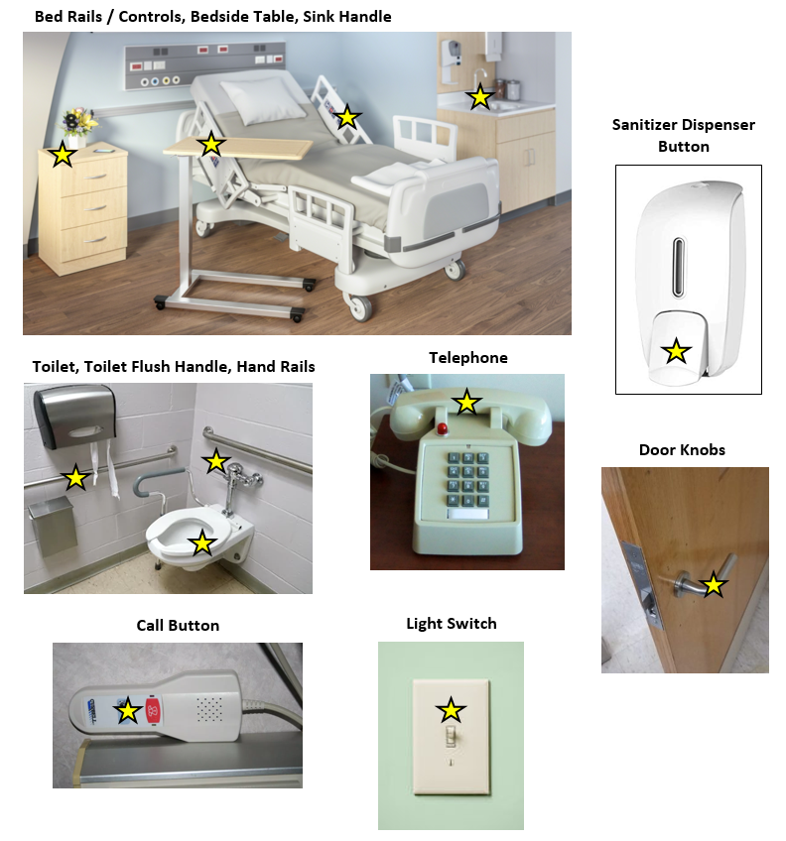

# UV Marker Removal Image Guide

UV Blacklight Marker

Refer to manufacturer’s instructions for use and the below guidance for acceptable levels for marking removal. In general, a surface is sufficiently cleaned is ***if the UV marker is at least 80% removed***.

Example Images Showing UV Marks **Removed** or **Not Removed**:

**UV MARKING SPRAY REMOVAL: DOOR KNOB**

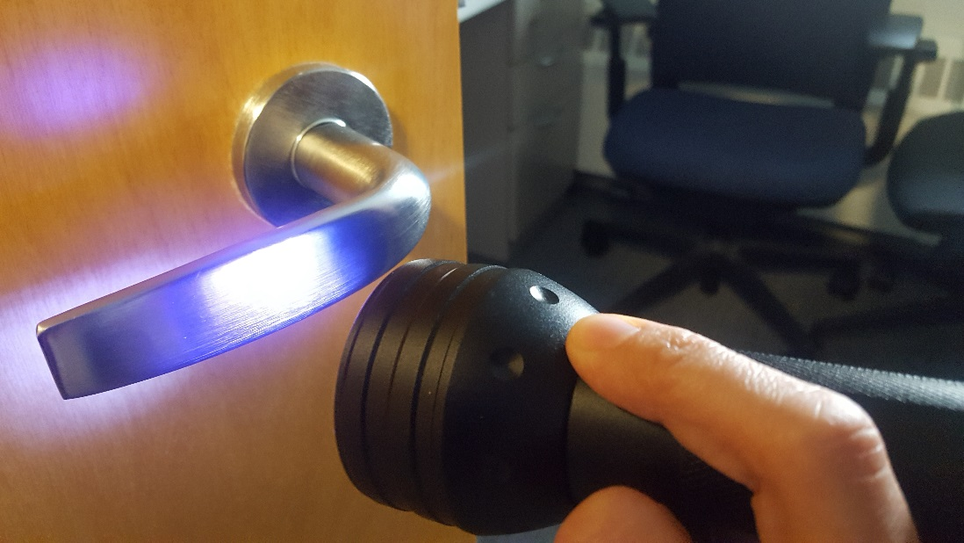 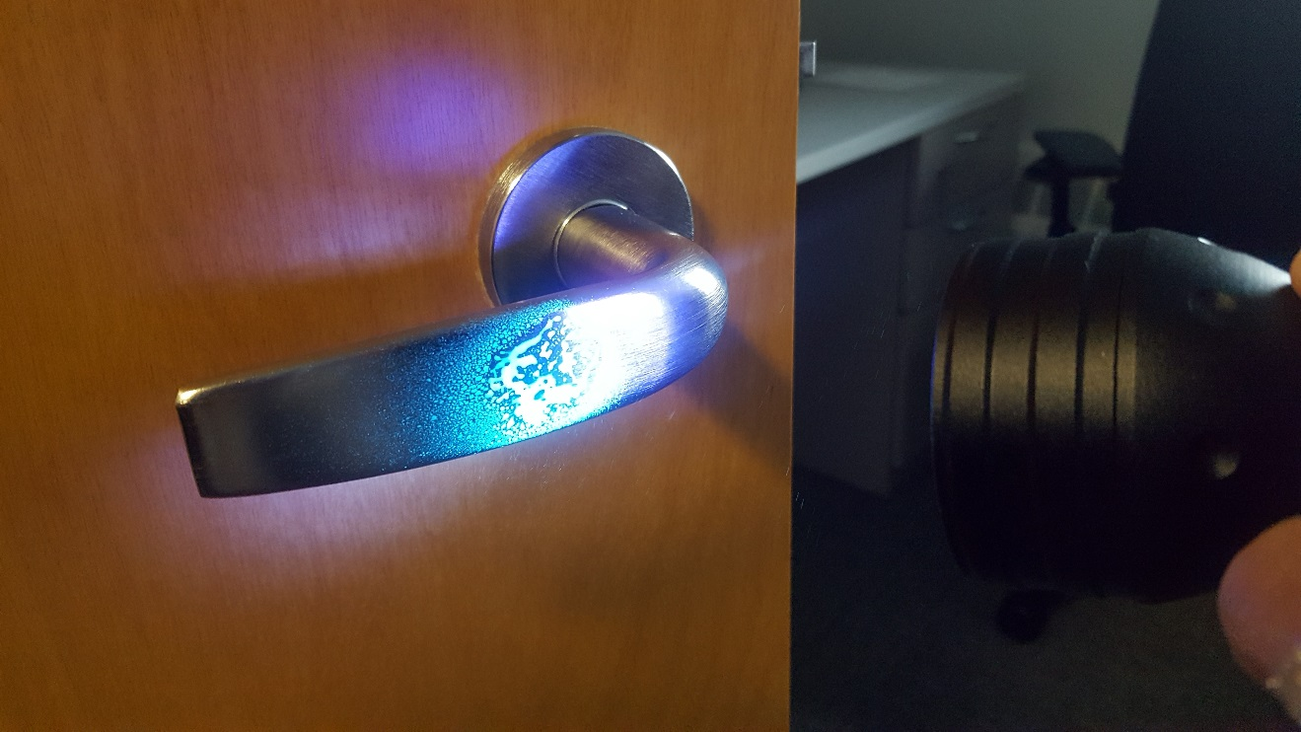

**Prior to UV Marking Spray UV Marking Spray: 0% Removed**

**Not Removed**

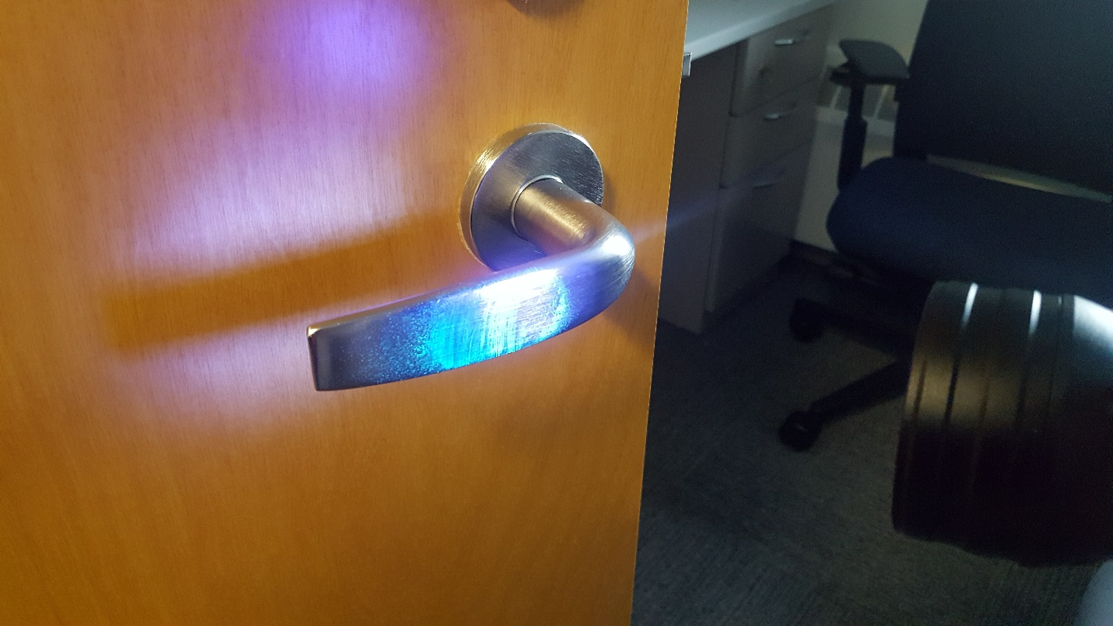 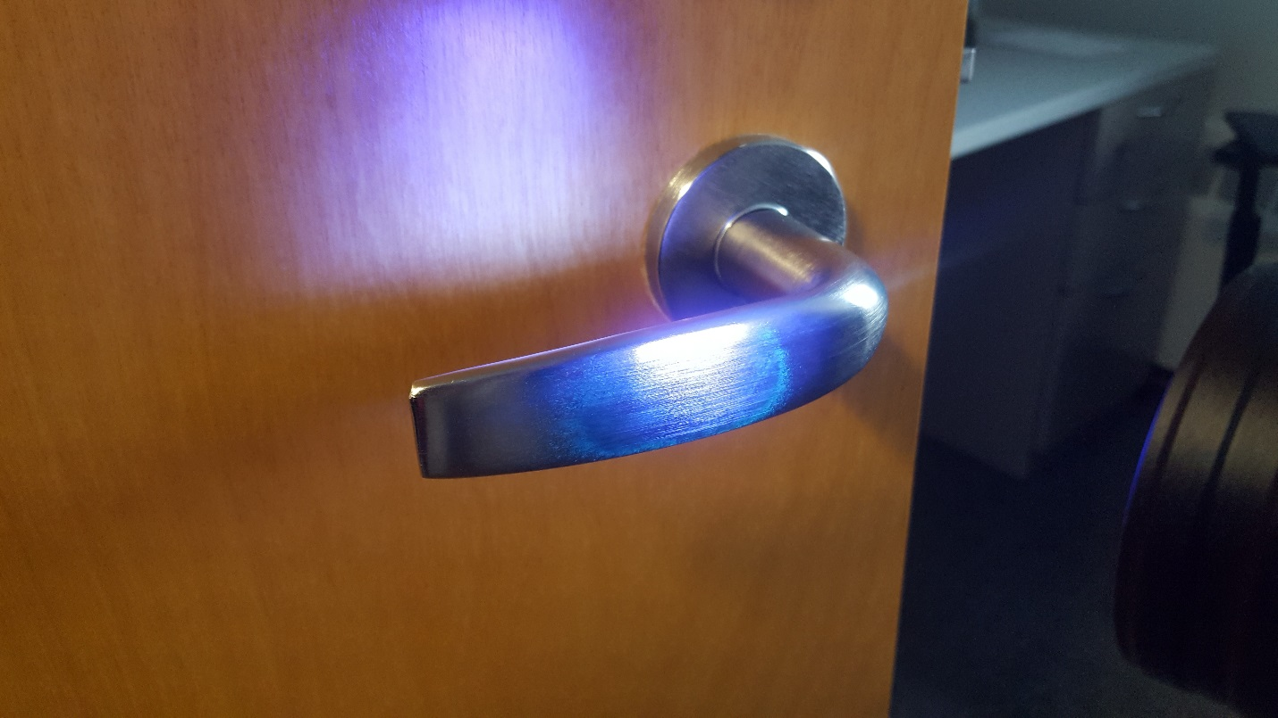

**UV Marking Spray: 40% Removed** **UV Marking Spray: >80% Removed**

**Not Removed Removed**

**UV MARKING SPRAY REMOVAL: LIGHT SWITCH**

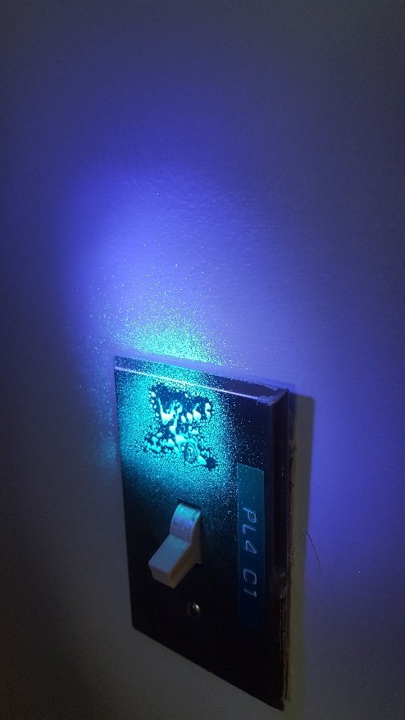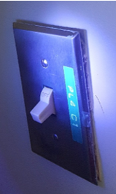

***Prior to UV Marking Spray UV Marking Spray: 0% Removed***

**Not Removed**

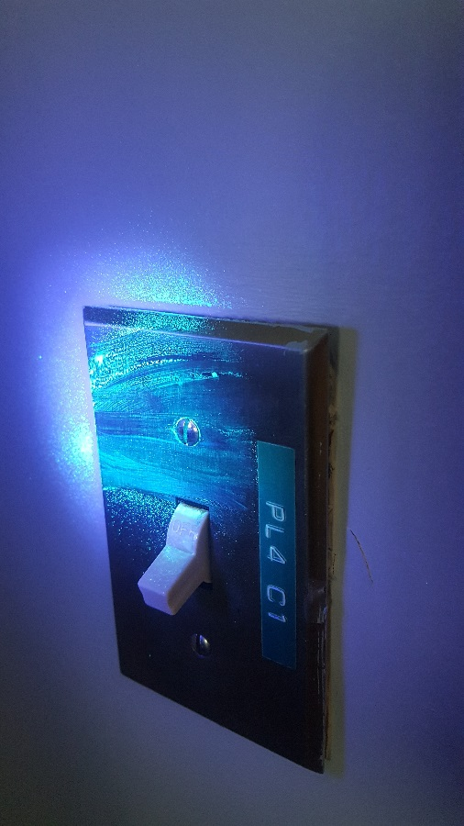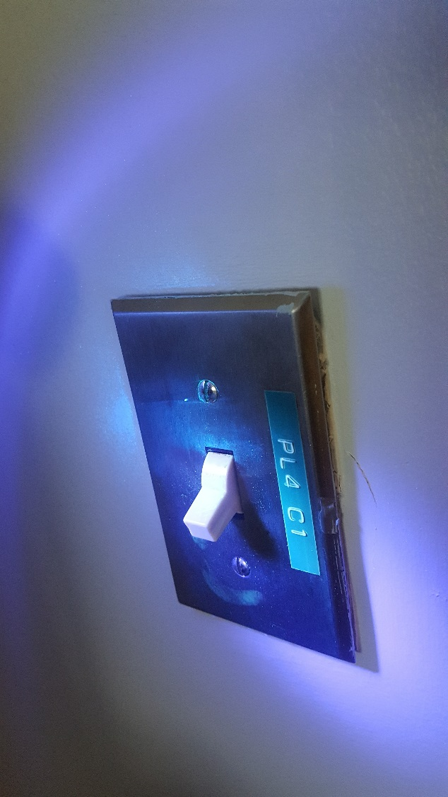

***UV Marking Spray: 40% Removed UV Marking Spray: >80% Removed***

**Not Removed Removed**

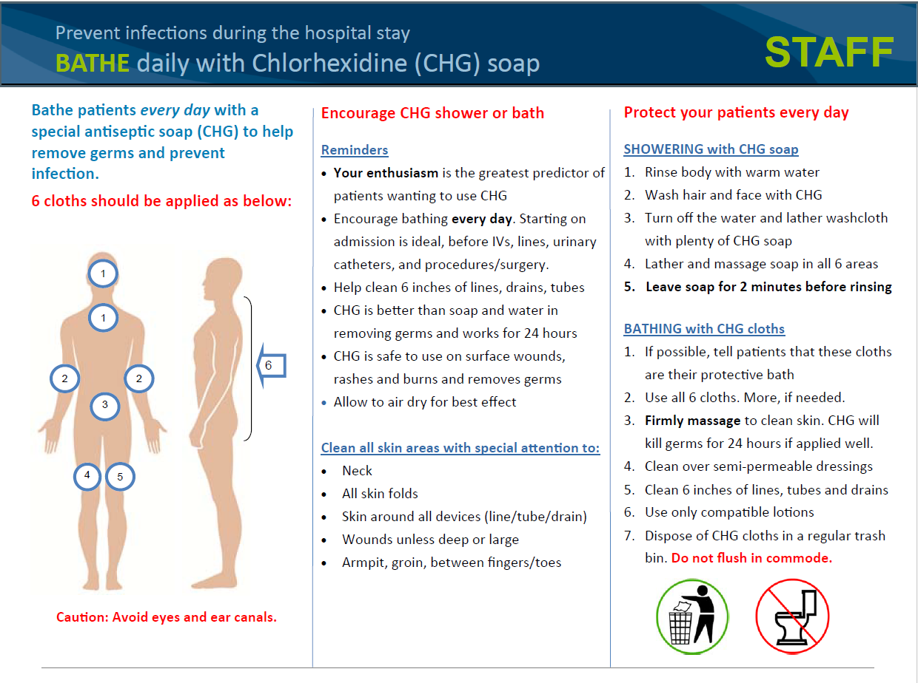

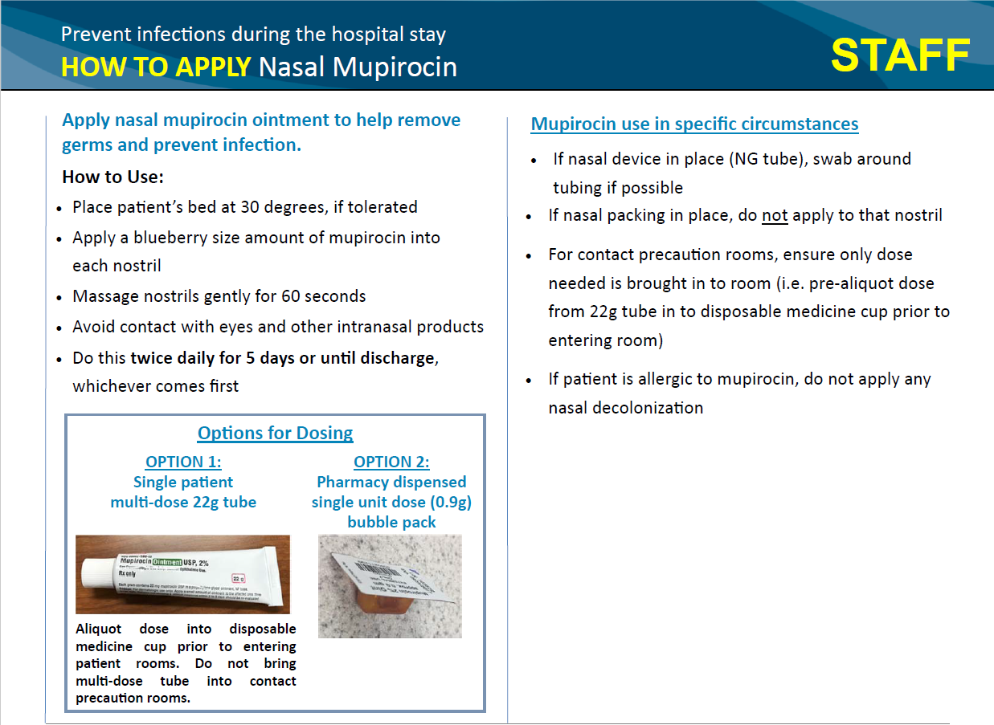

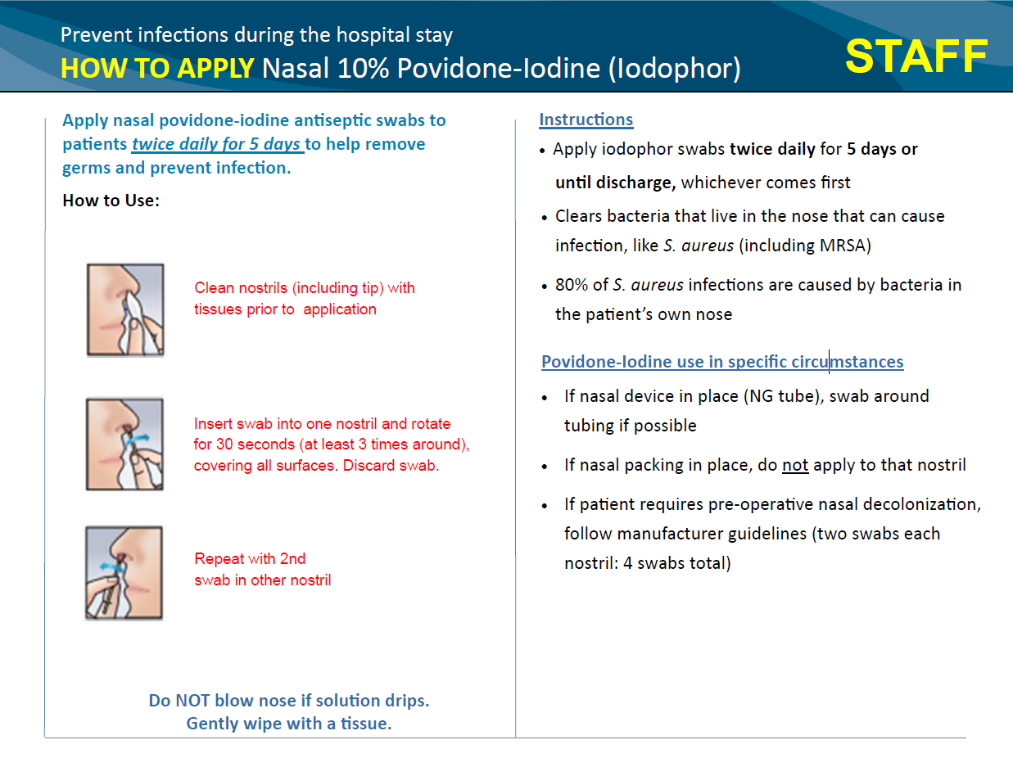

**Outbreak Response Logs**

Initial Response Log

1. Day 1-2 Outbreak Response Log: Tier 1
2. Day 1-2 Outbreak Response Log: Tier 2
3. Day 1-2 Outbreak Response Log: Tier 3
4. Day 1-2 Outbreak Response Log: Tier 4
5. Day 1-2 Outbreak Response Log: Tier 5

Weekly Monitoring

1. Weekly Intervention Log

# Day 1-2 Outbreak Response Log

**Facility Name: _________________________________ Submitted By: _________________________________**

1. Outbreak Progression Details:
   1. How was the outbreak identified (describe): Click or tap here to enter text.
   2. Outbreak descriptor: Click or tap here to enter text.
   3. Date & Time when outbreak was identified: Enter MMDDYY; 00:00 AM/PM
   4. Date & Time of collection of first isolate in outbreak: Enter MMDDYY; 00:00 AM/PM
   5. Number of patients when outbreak was identified: Click or tap here to enter text.
2. Organism: Click or tap here to enter text.
3. Unit Director notification: Y/N 3a. Date & Time: Enter MMDDYY; 00:00 AM/PM
4. Huddles with clinical staff have occurred: Y/N
5. Complete initial practice assessments (using Outbreak Response Assessment Forms) & record results:
6. Hand Hygiene Adherence Rate: ___________________%
7. Contact Precaution Adherence Rate: _______________% (Check here if N/A and not completed: )
8. Environmental Cleaning Adherence Rate: ___________%
9. Tier 2 intervention selected:
   1. Improve hand hygiene
   2. Improve contact precaution adherence
   3. Improve quality of cleaning
   4. Coordinated unit clean daily
   5. Additional cleaning of high touch areas
   6. Other (specify below)
10. Intervention implementation Date & Time: Enter MMDDYY; 00:00 AM/PM
    1. Description of intervention (indicate reason for selection, e.g. poorest adherence rate): Click or tap here to enter text.
11. Additional Comments: Click or tap here to enter text.

# Day 1-2 Outbreak Response Log: TIER 2 Progression of Outbreak

**Facility Name: _________________________________ Submitted By: _________________________________**

1. Outbreak Progression Details:
2. Outbreak descriptor: Click or tap here to enter text.
3. Date & Time when outbreak progression was identified: Enter MMDDYY; 00:00 AM/PM
4. Date & Time of collection of most recent isolate: Enter MMDDYY; 00:00 AM/PM
5. Number of additional patients: Click or tap here to enter text.
6. Please describe how the outbreak has progressed: Click or tap here to enter text.
7. Huddles with clinical staff have occurred: Y/N
8. Complete repeat practice assessments (if >1week has passed since initial assessments) & record results:
9. Hand Hygiene Adherence Rate: ___________________%
10. Contact Precaution Adherence Rate: _______________% (Check here if N/A and not completed: )
11. Environmental Cleaning Adherence Rate: ___________%
12. Tier 2 intervention selected:
13. Improve hand hygiene
14. Improve contact precaution adherence
15. Add universal glove precautions
16. Add contact precautions for outbreak patients
17. Improve quality of cleaning
18. Coordinated unit clean daily
19. Additional cleaning of high touch areas
20. Other (specify below)
21. Second intervention implementation Date & Time: Enter MMDDYY; 00:00 AM/PM
22. Description of intervention (indicate reason for selection, e.g. poorest adherence rate): Click or tap here to enter text.
23. Additional Comments: Click or tap here to enter text.

# Day 1-2 Outbreak Response Log: TIER 3 Progression of Outbreak

**Facility Name: _________________________________ Submitted By: _________________________________**

1. Outbreak Progression Details:
   1. Outbreak descriptor: Click or tap here to enter text.
   2. Date & Time when outbreak progression was identified: Enter MMDDYY; 00:00 AM/PM
   3. Date & Time of collection of most recent isolate: Enter MMDDYY; 00:00 AM/PM
   4. Number of additional patients: Click or tap here to enter text.
   5. Please describe how the outbreak has progressed: Click or tap here to enter text.
2. Huddles with clinical staff have occurred: Y/N
3. Leadership Notification? Y/N
   1. If yes, indicate who was notified:
   2. Describe guidance and/or recommendations received: Click or tap here to enter text.
4. Complete repeat practice assessments (if >1week has passed since initial assessments) & record results:
5. Hand Hygiene Adherence Rate: ___________________%
6. Contact Precaution Adherence Rate: _______________% (Check here if N/A and not completed: )
7. Environmental Cleaning Adherence Rate: ___________%
8. Tier 3 intervention selected:
9. Increase frequency of room cleaning
10. Universal contact precautions for unit
11. Weekly screening of patients on unit
12. Initiate decolonization of affected patients
13. Initiate decolonization of whole unit
14. Improved routine decolonization procedures
15. Other (specify below)
16. Additional intervention implementation Date & Time: Enter MMDDYY; 00:00 AM/PM
    1. Intervention description: Click or tap here to enter text.
    2. If ‘Improved decolonization’ intervention is selected, record assessment results:

CHG Bathing Practices Adherence Rate: ___________% (Check here if not completed: )

1. Additional Comments: Click or tap here to enter text.

# Day 1-2 Outbreak Response Log: TIER 4 Progression of Outbreak

**Facility Name: _________________________________ Submitted By: _________________________________**

1. Outbreak Progression Details:
2. Outbreak descriptor: Click or tap here to enter text.
3. Date & Time when outbreak progression was identified: Enter MMDDYY; 00:00 AM/PM
4. Date & Time of collection of most recent isolate: Enter MMDDYY; 00:00 AM/PM
5. Number of additional patients: Click or tap here to enter text.
6. Please describe how the outbreak has progressed: Click or tap here to enter text.
7. Huddles with clinical staff have occurred: Y/N
8. Leadership Notification? Y/N
   1. If yes, indicate who was notified:
   2. Describe guidance and/or recommendations received: Click or tap here to enter text.
9. Complete repeat practice assessments (if >1week has passed since initial assessments) & record results:
10. Hand Hygiene Adherence Rate: ___________________%
11. Contact Precaution Adherence Rate: _______________% (Check here if N/A and not completed: )
12. Environmental Cleaning Adherence Rate: ___________%
13. Tier 4 intervention selected:
14. Increase frequency of room cleaning
15. Universal contact precautions for unit
16. Weekly screening of patients on unit
17. Initiate decolonization of affected patients
18. Initiate decolonization of whole unit
19. Improved routine decolonization procedures
20. Other (specify below)
21. Additional intervention implementation Date & Time: Enter MMDDYY; 00:00 AM/PM
22. Intervention description: Click or tap here to enter text.
23. If ‘Improved decolonization’ intervention is selected, record assessment results:

CHG Bathing Practices Adherence Rate: ___________% (Check here if not completed: )

1. Additional Comments: Click or tap here to enter text.

# Day 1-2 Outbreak Response Log: TIER 5 Progression of Outbreak

**Facility Name: _________________________________ Submitted By: _________________________________**

1. Outbreak Progression Details:
2. Outbreak descriptor: Click or tap here to enter text.
3. Date & Time when outbreak progression was identified: Enter MMDDYY; 00:00 AM/PM
4. Date & Time of collection of most recent isolate: Enter MMDDYY; 00:00 AM/PM
5. Number of additional patients: Click or tap here to enter text.
6. Please describe how the outbreak has progressed: Click or tap here to enter text.
7. Huddles with clinical staff have occurred: Y/N
8. Leadership Notification? Y/N
   1. If yes, indicate who was notified:
   2. Describe guidance and/or recommendations received: Click or tap here to enter text.
9. Complete repeat practice assessments (if >1week has passed since initial assessments) & record results:
10. Hand Hygiene Adherence Rate: ___________________%
11. Contact Precaution Adherence Rate: _______________% (Check here if N/A and not completed: )
12. Environmental Cleaning Adherence Rate: ___________%
13. Tier 5 intervention selected:
14. Deep clean unit
15. Screen staff
16. Other (specify below)
17. Additional intervention implementation Date & Time: Enter MMDDYY; 00:00 AM/PM
18. Intervention description: Click or tap here to enter text.
19. Additional comments: Click or tap here to enter text.

# 

# Weekly Intervention Log

Complete Intervention Log weekly, following implementation of response protocol.

Weekly Log should capture repeat practice assessment results for the week being reported.

Continue weekly reporting for duration of intervention, should it exceed the standard 3 weeks.

**Facility Name: _______________________________ Submitted By: _________________________________**

1. Outbreak descriptor: Click or tap here to enter text.
2. Outbreak Response Tier:

Tier 1  Tier 2  Tier 3  Tier 4  Tier 5

1. Indicate which week of the intervention that is being reported here:

Week 1  Week 2  Week 3  Week 4  Week 5  Week 6

1. Intervention selected:

Tier 1 & 2 options

1. Improve hand hygiene
2. Improve contact precaution adherence
3. Add universal glove precautions
4. Add contact precautions for outbreak ___patients
5. Improve quality of cleaning
6. Coordinated unit clean daily
7. Additional cleaning of high touch areas

Tier 3 & 4 options

1. Increase frequency of room cleaning
2. Universal contact precautions for unit
3. Weekly screening of patients on unit
4. Initiate decolonization of affected patients
5. Initiate decolonization of whole unit
6. Improved routine decolonization procedures

Tier 5 options

1. Deep clean unit
2. Screen staff
3. Intervention implementation Date & Time: Enter MMDDYY; 00:00 AM/PM
4. Results of repeated practice assessments from this past week (complete only those applicable):
   1. Hand Hygiene Adherence Rate: ___________________% (Check here if not completed: )
   2. Contact Precaution Adherence Rate: _______________% (Check here if not completed: )
   3. Environmental Cleaning Adherence Rate: ____________% (Check here if not completed: )
   4. CHG Bathing Practices Adherence Rate: _____________% (Check here if not completed: )
5. Additional Comments: Click or tap here to enter text.
6. Please indicate if this outbreak was reported to your local or state health department (check one):

Not reported  Reported to state health department; report date: Click or tap here to enter text.

Reported to local health department; report date: Click or tap here to enter text.